Application Deployment on WebSphere® Application Server ND - Cluster Environment.

Step 1: Login to console.
Screenshot 1:
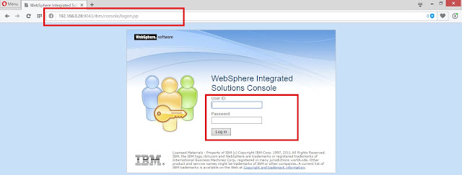
Step 2: Go to Applications >> Application Types >> WebSphere enterprise applications >> Install
Screenshot 2:
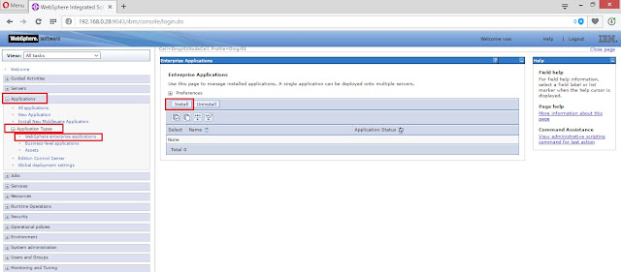
Step 3: Choose the file from local machine or Remote machine. { i have choose'n Local Machine }
Screenshot 3:
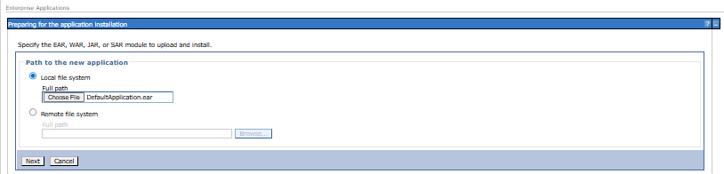
Step 4: Select the deployment file >> open
Screenshot 4:
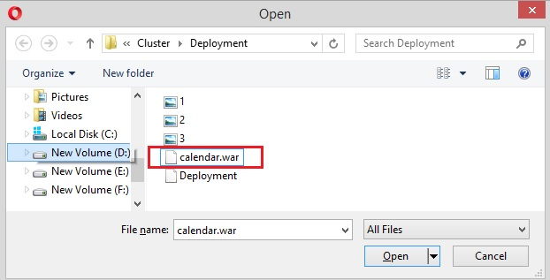
Step 5: Review the selected file >> Next
Screenshot 5:
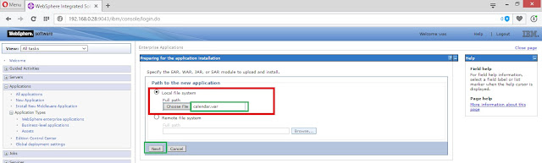
Step 6: Choose the Fast Path >> Next
Screenshot 6:
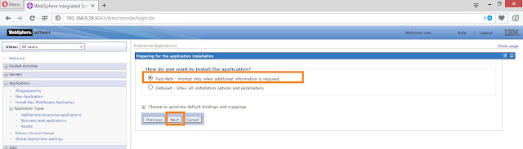
Step 7: Review the application name / Directory to install application -- on another location >> Next
Screenshot 7:
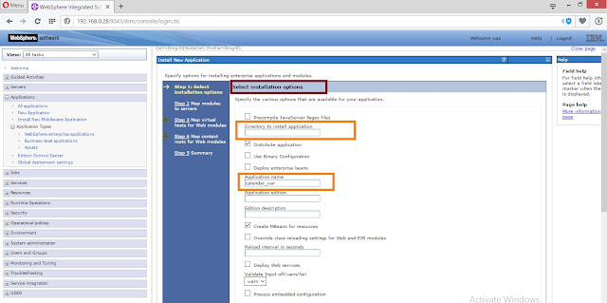
Step 8: Review the map modules to the cluster / cell .
Screenshot 8:
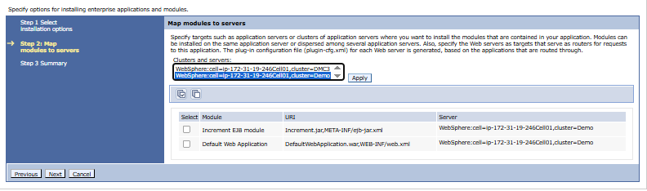
Step 9: Select the default host >> Next.
Screenshot 9:
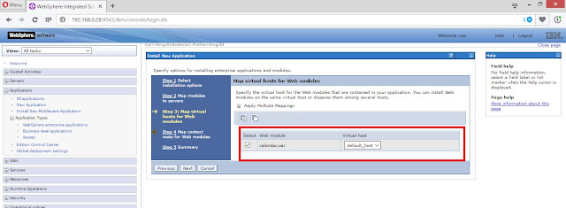
Step 10: provide the context root for application .
Screenshot 10:
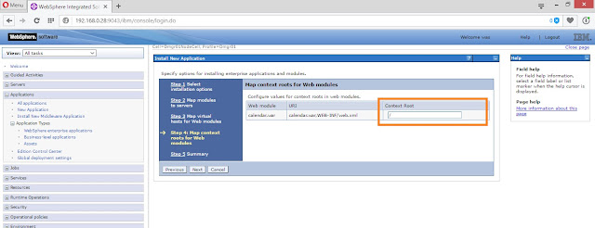
Screenshot 11:
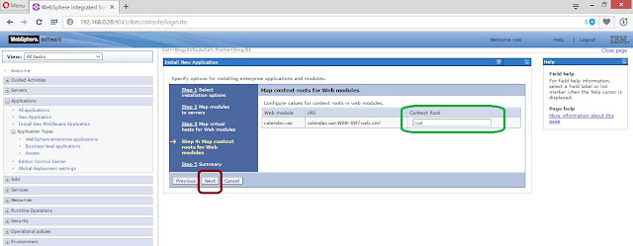
Step 11 : Review the Summary >> Finish
Screenshot 12:
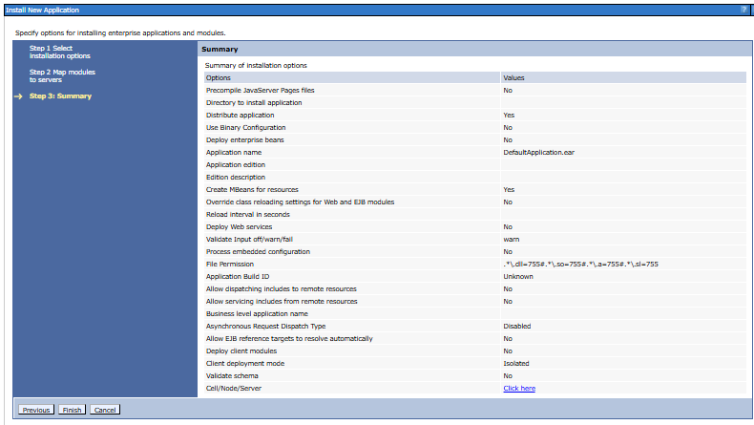
Step 12: Click on Review.
Screenshot 13:
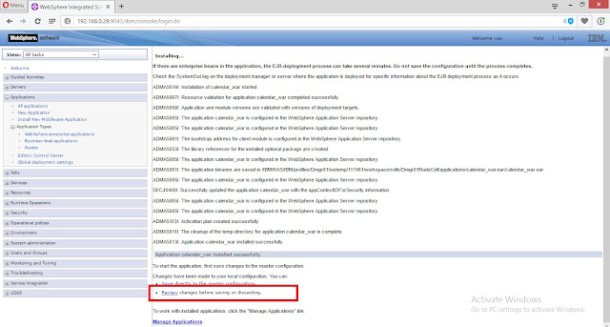
Step 13: Select "Synchronize changes with Nodes" >> Save.
Screenshot 14:
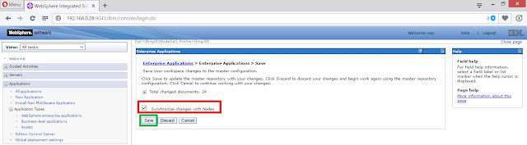
Step 14: Review the current status of the Nodes being synchronized >> OK
Screenshot 15:
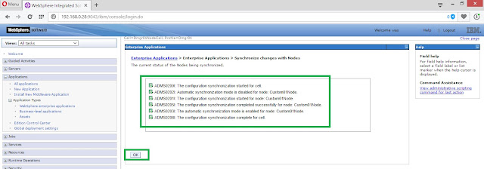
Step 15: Application is being deployed , status is "Stopped".
Screenshot 16:
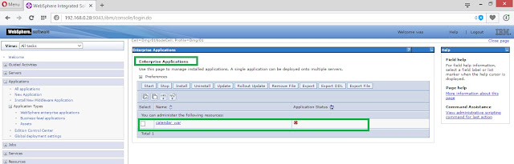
Step 16: Select the calendar_war Application >> Start.
Screenshot 17:
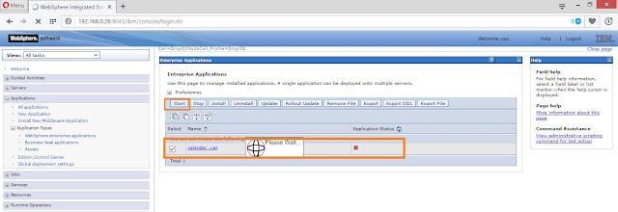
Screenshot 18 : calendar_war Application is "Started".
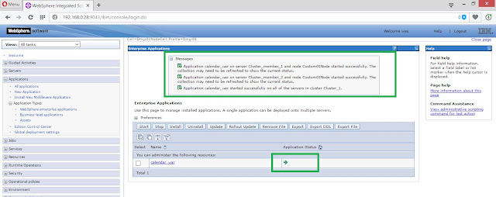
Step 17 : check the application using URL >>
http://192.168.0.28:9080/cal/
where,
cal - context root.
192.168.0.28 - ip / hostname.
9080 - WC_defaulthost
Screenshot 19:
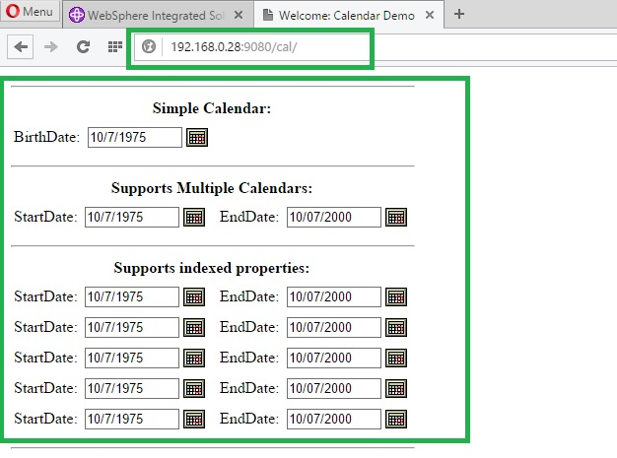

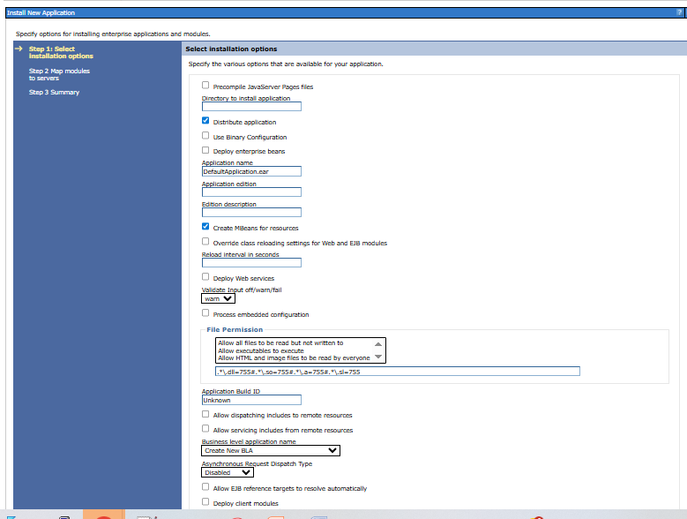

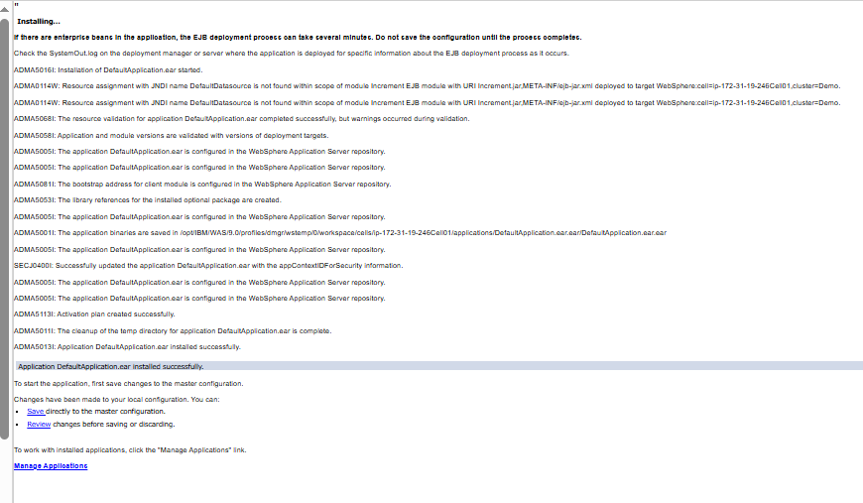

Installed - /opt/IBM/WAS/9.0/profiles/AppServ05/installedApps/ip-172-31-19-246Node02Cell - Installed app.
